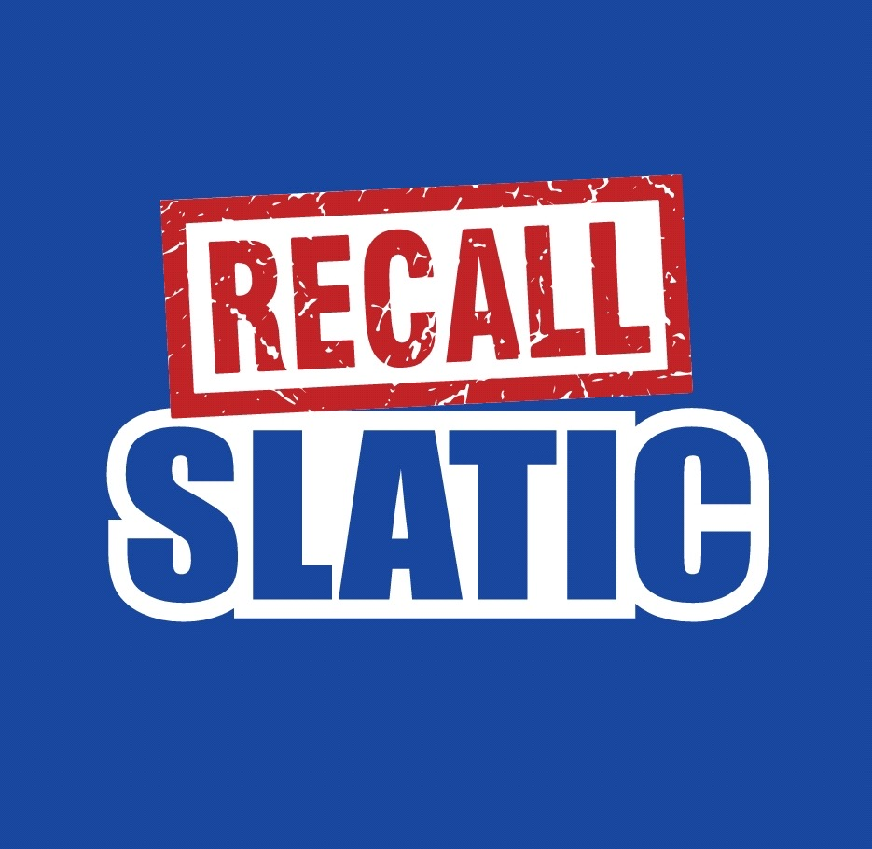
Come Stand With Students, Teachers & Staff to Recall
Terry Slatic
November 10th from 4:30 to 7:30pm
Elks Lodge
5351 N Diana St
Join us as we move forward in the Recall Process. Food, DJ , No Host Bar, & FUN.
Sponsorship Opportunities Available. Gold $600, Silver $300 Bronze $150
http://recallslatic.com/donate-now/
We Will Have a Swag booth to get your Buttons, Car Magnets, Yard signs and more!
Our Field Coordinator will be there to answer questions on volunteering.
Contact Committee with questions 559-492-6798
Email RecallSlatic@gmail.com
https://www.eventbrite.com/e/recallslatic-fundraiser-tickets-79383637597

